ISLANDING DETECTION WITH PHASOR MEASUREMENT UNITS

Jorge Cardenas, GE Digital Energy, Spain
George Mikhael, GE Digital Energy, Spain
Jacek Kaminski, GE Digital Energy, Spain

SUMMARY

The following paper briefly describes the problems caused by the Islanding operation in power systems and describes different methods to detect the islanding condition in photovoltaic applications. Finally it explains a proposal for a secure method of islanding detection using synchrophasors: The algorithms were verified with Real Time Digital Simulator (RTDS) tests and tests in laboratory using an inverter connected to grid, in order to perform automatic and manual decisions to assure the correct and secure operation of the distribution grid.

Keywords: Islanding, Synchrophasor (PMU), Distributed Generation, Non detection Zone (NDZ), Magnitude difference, Angle shift, Frequency Drift, Passive Islanding Detection

INTRODUCTION
Due to the growth of renewable energies, especially wind and photovoltaic sources, a new concept of generation called Distributed Generation (DG) has been developed. This system generates renewable energy in the distribution grid near the loads, in order to avoid losses produced in the transmission lines. On the other hand, technical requirements of public services connected to the electric grid must be satisfied in order to maintain proper security and protection for both people and the installation, and to ensure the reliability of the grid. Therefore, it is important to have a protection system that can accurately identify islanding conditions.
“Islanding is a condition in which a portion of the utility system, which contains both load and generation, is isolated from the remainder of the utility system and continues to operate. The isolation point is generally on the low voltage distribution line when an islanding condition exists, but islanding may also occur on the higher voltage distribution or transmission lines when large numbers of PV and other distributed generation are present” [1, p. 6].

ISLANDING SITUATION
An islanding condition can be produced by the following events:
- A fault produced in the grid which results in a disconnection that is not detected by the photovoltaic inverter or the protection equipment
- An accidental opening of the connection point with the electrical company
- Programmed disconnection
- An intentional opening of the connection point with the electrical company
- Human errors
- Natural causes
Anti-islanding system requirements

Expanded distributed networks pose a challenge to quick detection of islanding, especially if the power mismatch between generated power and the load in the island is minimal. The goal of this paper is to find an optimal combination of algorithms that will generate the smallest Non Detection Zone (NDZ) and will operate as quickly as possible. The reason for which is to evade the following hazards:
- Generally, voltage and frequency anti-islanding control systems are not incorporated in the Electrical Grid SCADA systems. During an islanding condition, the voltage and frequency may be within the band defined for nominal values, but the inverter is not capable of regulating these parameters and therefore a hazardous situation will result for the client equipment.
- The electrical companies can be penalized by the users when there are hazards in the PV devices as a result of having the voltage and frequency parameters out of the acceptable ranges.
- The islanding situation can create a hazardous situation for the operators in the electric installations and for the public in general, since circuits which are assumed to be disconnected from their sources, are actually energized.
- The reconnection of the electric system with the islanding can have as a result a new disconnection or a hazard in the equipment if the connection is happens in an out of phase situation, since there is no control of the islanding voltage and frequency.
- The islanding condition can interfere with the manual or automatic service reestablishment process after an important event in the electric system.
There are several different approaches and agreements/standards in the international community about the methods to apply for islanding situation detection. Some countries as the Netherlands only demand frequency derived passive systems that stop the inverters. Other countries as Germany and Austria use specific methods based on impedance change in use of monitoring units and switching devices, known as ENS or MSD. In the United States, there has been an adoption of standards that oblige the inverter manufacturers to incorporate elements to detect islanding and disconnect the DG after determined out of tolerance conditions exist in the island or in the Electric System [2] [5].

MOST COMMON ISLANDING DETECTION METHODS
Referring to [1], there are several islanding condition detection methods and are divided into three groups as follows:

Passive methods

“Passive methods can monitor variables of the distributed grid in order to find abnormal changes in, for instance, frequency, voltage amplitude, phase angle, harmonics contents, etc. Passive methods can be effective in most situations. However, their non-detection Zone (NDZ), e.g., the range of loads for which the islanding detection method may fail, can be large” [3, p. 1].

- Maximum/minimum voltage
- Maximum/minimum frequency
- Vector jump
- Voltage harmonic measurements

Active methods

“Active methods can detect a main grid power disconnection on the basis of observations on the response of the distributed grid to a disturbance intentionally introduced by the method. The response, or its magnitude, depends on the presence of the main grid power. Thus, islanding conditions may be determined on the basis of the response. In this manner, the NDZ can be minimized” [3, p. 1].

- Measurement of the system impedance
- Impedance detection at the determined frequency
- Frequency variation in sliding window mode
- Frequency threshold
- Frequency variation
- ENS or MSD (one equipment using some methods)

Communication-based methods

“Communication-based methods usually operate on the basis of establishing communication channels between distributed generators and the main grid. Communications based methods can detect islanding conditions even when the power produced matches the power consumed. However, the communications devices can be expensive. Implementing a communication-based method may also call for co-operation of the main grid provider” [3, p. 1]. Common communication-base methods are :

- Signal Produced by Disconnect
- Using Power line Carrier Communications
- SCADA (Supervisory Control and Data Acquisition)

NEW DETECTION PROPOSAL
Many of currently applied solutions listed in previous chapter are limited by associated costs and the availability of facilities. Moreover, it is not easy to keep the selectivity on island conditions and maintain the acceptable level of NDZ at the same time.

The goal of this paper is to present a trustworthy solution with an application based on passive detection methods which do not interfere with the system, and can be used in any point of the grid. These methods have been combined with synchrophasor technology to create a faster and more reliable solution.

Synchrophasors

Synchrophasors accurately measure and analyze the state of the power system based on real-time data collected from Phasor Measurement Units (PMUs) located across the network. Through collection of accurately GPS time-tagged phasor data, system operators can quickly identify power system events through visualization of system quantities such as power flow, dynamic phase angle separation, and the rate of change of frequency from different parts of the system.

Synchrophasors are based on phasor representation of sinusoidal signals which are commonly used in AC power system analysis. The sinusoidal waveform defined:

is commonly represented as the phasor:

where the magnitude is the RMS value, , of the waveform and the subscripts r and i signify real and imaginary parts of a complex value in rectangular components [4].

The IEEE C37.118-2011 standard contains details about synchrophasor definitions and measurements.
IMPLEMENTATION
Devices and communication

The PMUs and algorithms are implemented as part of a pilot project to identify the separation of one part of the Electrical System (Island) where the island contains one photovoltaic source and several loads of different characteristics. For that purpose two Phasor Measurement Units (PMU) were installed in the field, one inside the island and other one in the main grid, connected to a Phasor Data Concentrator (PDC), which will time align the data received from PMU’s and forwarding it to a PC running a soft PLC. Figure 1 shows the setup of the PMUs and PDC, and illustrates the data flow and the overall concept.

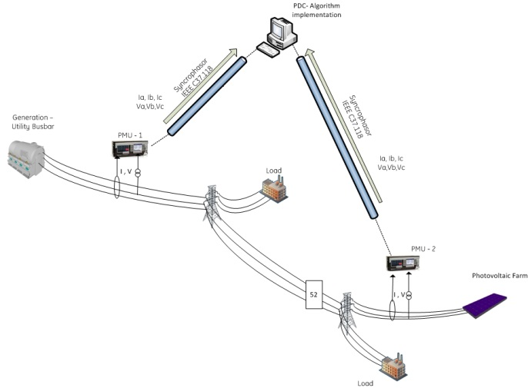
Figure 1. Units connection
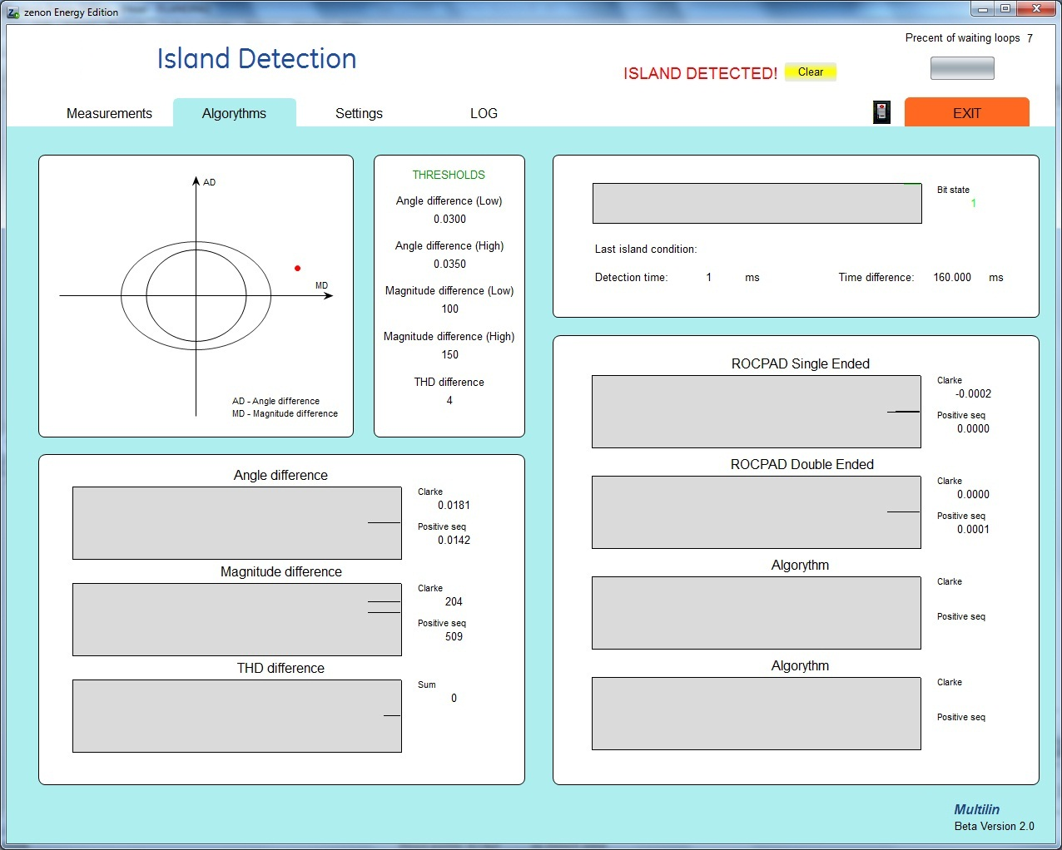
Figure 2. Software interface

As a PMU device, standard feeder protection system with synchrophasor capability has been used. As a data concentrator the substation hardened high performance device capable of collecting, processing, recording and archiving C37.118 compliant synchrophasor data was used.

Algorithm identification and verification

In order to achieve the minimum Non Detection Zone (NDZ), several methods were checked for their ability of accurate islanding detection. The algorithms listed below utilize synchrophasor technology and are based on comparing measurements received from two points of the system, as mentioned in the first part of this chapter.
Moreover, the phasors used for algorithms are the result of the mathematical Clarke Transformation, which simplifying three-phase system measurements in to one phase system. Clark transform is given by the following equations:

In this implementation α = 45˚. S could be either current or voltage.

Angle Difference. Angle difference method indicated an islanding condition if the difference of angles of respective voltage signals received from two points of the system exceeds a programmable threshold. The angles of the positive sequence voltage and the voltage calculated from the Clarke transformation were both tested and compared.

Voltage Difference. The voltage difference method operates similarly to the angle difference method. It compares the magnitudes of the voltage phasors obtained from Clarke transformation.

ROCPAD (Rate of Change of Phase Angle Difference). The following algorithms of ROCPAD have been tested with using the positive sequence voltage and the Clarke transformation voltage phasors.

Single ended. This method calculates the rate of change of the angle difference between respective voltage and current signals. It using measurements only from one PMU attached to island area.

The islanding condition is detected whenever the value of ROCPAD exceeds a settable threshold.

Double ended. The double ended ROCPAD uses values from both sides of the system and operates whenever the result of differences exceeds a programmable threshold.

THD Difference. This novel method calculates the sum of Total Harmonic Distortion (THD) of the voltages from each PMU and compares the difference of the sums of THD

Note that this method is suitable in case significant THD different between grid side and DG side is measured. The PV system with inverter used in this study has measurable THD difference. Instead of voltage THD, current THD may be utilized. Moreover, THD algorithm is not immnue to other network events such as faults and loads, therefore additional supervisory conditions may be required.

All these methods were implemented in a soft PDC logic software. In a programming environment developed which allows calculating phasors values in real time and allow for manipulation of these values in order to implement the algorithms.

The created application contains several features such as a graphical human interface and allows changing particular settings to adjust protection for smaller NDZ.

RTDS TESTS
The RTDS is a Real Time Digital Simulator which has the capability of simulating the power system in real time. Real time means that it can operate breakers, force faults, or make changes in the power system without having to turn off and rerun the simulation runtime. This is done thanks to various processing units that are utilized in parallel which give the RTDS a high computational power. The calculations are done in every step time, with typical values of step times lying between 50µs and 120µs.

The RTDS generates command signals that are interpreted by the amplifiers who then generate the currents and voltages needed for the testing as demonstrated in figure 3.

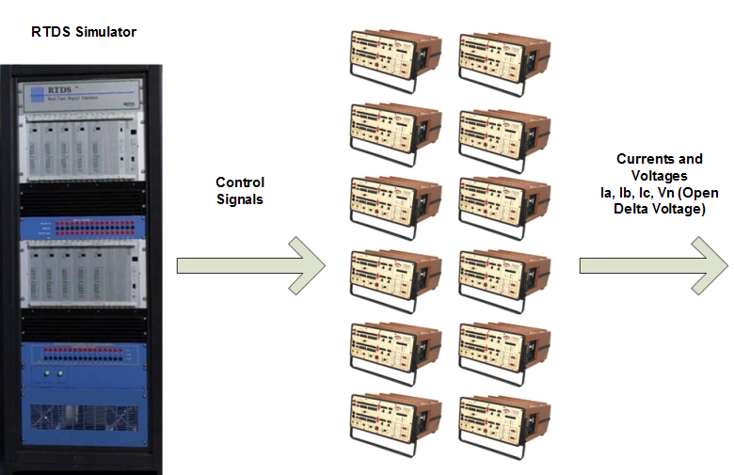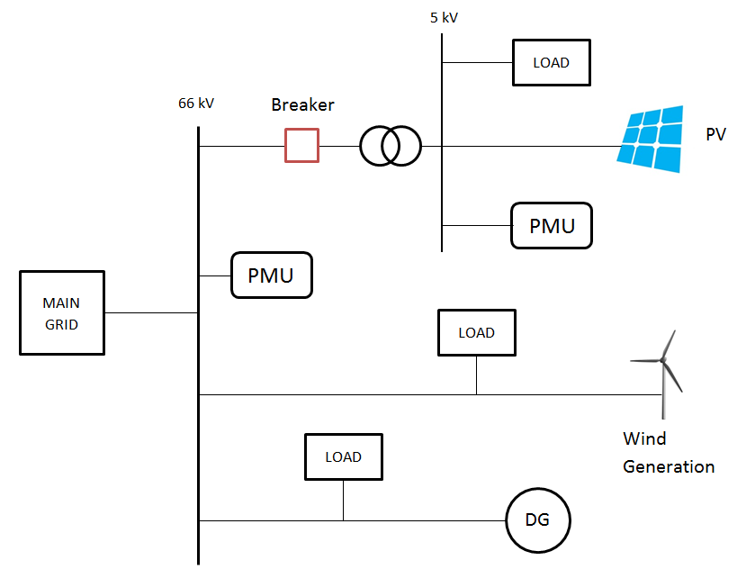

Figure 3. RTDS – Synchrophasors Test connection overview
Figure 4. RTDS – Grid model overview

RTDS tests has been made on a distribution network model, which contained main 66kV grid with a conventional power source, wind generation, cogeneration, and several loads plugged in different points. A 5kV network is also modelled as a potential island with photovoltaic generation and its own loads connected to main grid via a circuit breaker (figure 4). Island conditions are occurs when the breaker opens. In that case, the part of the system with solar generation power and some amount of a load are separated from the rest of the network. During the simulation the load inside the island was changed for test each algorithm for different power mismatches.

These tests have been made for 3 cases dependent on the power mismatches between power generated in distribution source (P_{gen}) and power used in island area (P_{load}).

FINAL LOGIC
The best way to minimize the Non Detection Zone and create a reliable solution is to choose the most effective methods and combine them in the PLC logic. For this purpose three algorithms have been chosen.

- Angle difference of Clarke voltage transformation, as the most effective and safest method
- Magnitude difference of Clarke voltage transformation, as an auxiliary condition for decreasing the Non Detection Zone
- THD difference is the fastest solution, but has the disadvantage of being prone to maloperation for other network changes such as faults or load connection. However, these weaknesses is overcome by a special logic explain later.

First algorithm – Angle and Magnitude difference

The first algorithm logic combines two methods: the angle difference and magnitude difference. Both of them are the difference of Clarke transformation voltage. This creates an oval characteristic, which is a threshold for the algorithm (Figure 5 5). If the operating quantity moves into the operating zone, then the island detection flag will be activated.

Second algorithm – Angle difference Speed and angle difference

This logic is based on the rate of change of angle difference. Unlike ROCPAD, it is based on the same Clake voltage angle difference. The axis of ordinates includes the rate of change of angle difference and the axis of abscissa includes angle difference. Combining the difference and rate of change of angle creates the characteristic (in Figure 6). In steady

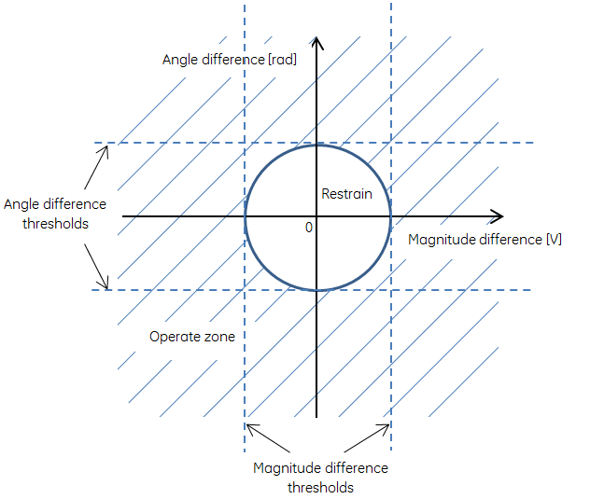
Figure 5 Angle and magnitude difference logic overview

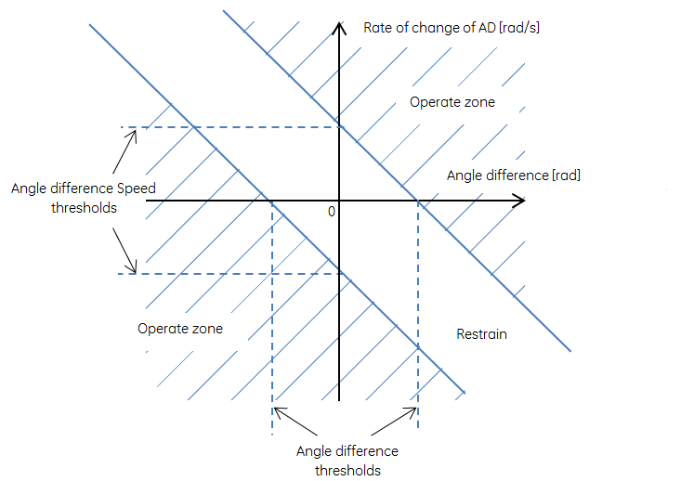
Figure 6 Angle difference and speed logic overview

state operation of the system, the operating point is at zero point in the graph. During island conditions both of values will shift, and move the operating quantity out of the restraining zone.

Third algorithm – THD difference

This algorithm is based on the THD equation explained previously. An island condition is identified if the subtraction of the sums of THDs exceeds a set threshold. Furthermore, to avoid undesirable operations, additional conditions must be fulfilled. In case of island disconnection from the grid and loss of the voltage stability, an increase of the harmonics participation can be observed. Meanwhile in main grid, the THD level is controlled by a high power source, and effects of the disconnection of the island from the main grid can have a positive impact on the voltage stability. Basis on this pattern, the following logic condition has been implemented: The THD level in island has to increase while the THD in the main grid remain the same or decrease. Only then shall the detect flag be set.

All algorithms include a time delay to allow the operation of other protection functions and to increase security.

Non Detection Zone

Figure 7 presents the operation time of each algorithm with respect to power mismatch. The choice of thresholds was based on theory and observations.

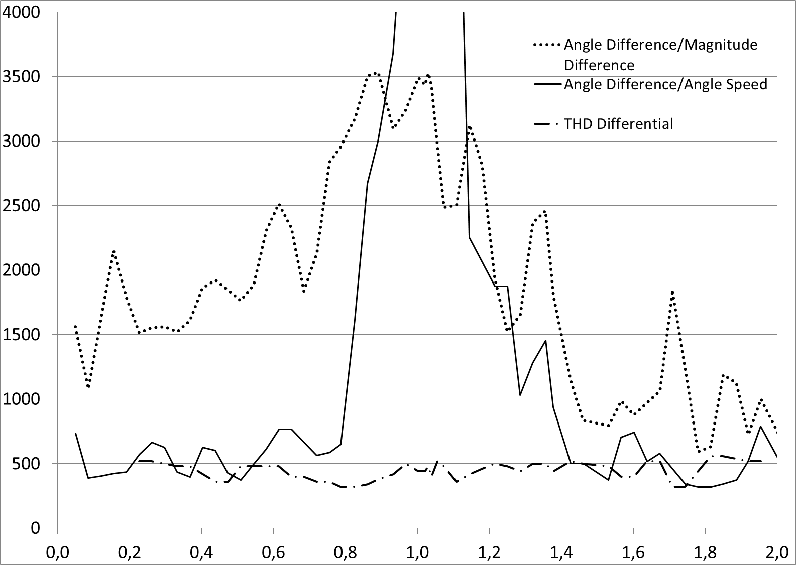
Figure 7 Non Detection Zone overview

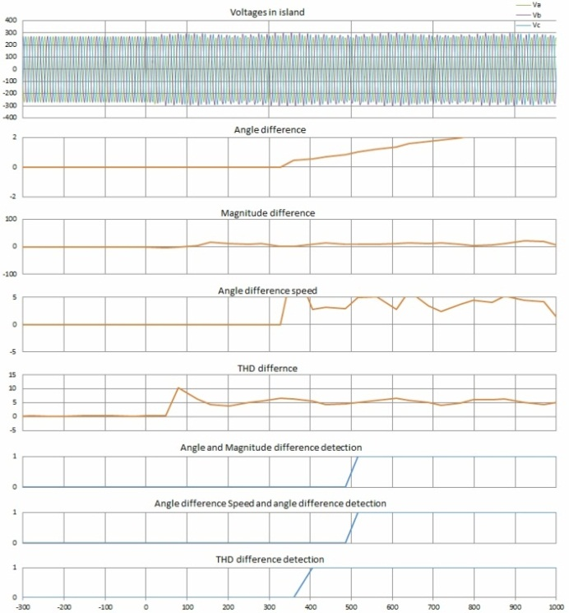
Figure 8 Algorithms and logic time curves (Pgen ≈ Pload)

7 shows that the power unbalance plays a significant role in the operation time of first two algorithms. The method based only on angle difference has best results in high power mismatches and is more reliable. On the other hand, it fails when the net power flow in the interconnection point is equal to zero. In turn, the algorithm which contains magnitude difference, had the worst results, except for the point when Pload/Pgen ≈ 0. Separately, the algorithms have their weaknesses, but a combination of the two algorithms can give satisfactory results.

Finally the THD algorithm has good time results for all power mismatches; mostly less than 500 ms. The combination of all three algorithms in the final application eliminates the NDZ problem.

TEST IN LABORATORY USING AN INVERTER CONNECTED TO GRID
The selected algorithms was been tested on a small test grid 3x400V in external laboratory. The sensitivity of each algorithm was tested depending on the power mismatch. The immunity against network events such as faults or load changes was also tested. Because of the internal inverter’s protection the algorithms were only tested in the inverter’s restrain area, where the power mismatch is minimal and the variation in voltage or frequency values was below inverter’s internal protection detection ability.
Figure 8 presents island conditions with minimal power unbalance. The island occurred at time = 0 and it had immediate impact on the THD. The island flags were activated after 400 ms for the THD method and 520 ms for first and second algorithms, respectively. In this case the internal inverter’s islanding protection did not detect the island conditions and continued operation. This is a hazard because, as shown, the voltage is not stable.

Fault events did not cause the activation of the island detect flags except for the THD algorithm. However, logic conditions block the algorithm’s activity as long as the same changes occur on both sides of the point of interruption. Moreover, the time delay of algorithms is set so as to allow other line protection functions to operate.

Load injection tests were also performed. The sudden connection of loads of 1.4kW and 27.0kW did not cause the activation of any algorithm, which would have been unwanted.

COMMUNICATION TESTS USING RADIOS
Tests were made with radio in order to verify the possibilities for transferring the synchrophasors. Two pairs of radios have been used to make stable duplex connection between one of PMU and PDC, using TCP protocol. Connection scheme used, shown below on figure 13.

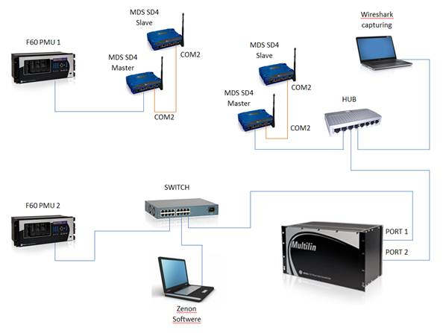
Figure 13 Connection of radio equipment

P flow | Diff/Mag | Angle | THD
[MW] | [ms] | [ms] | [ms]
-4.35 | 2800 | 1800 | 900
-1.94 | 3720 | 1120 | 900
-1.05 | 5000 | 4720 | 940
-0.35 | 6920 | 4600 | 1080
0.3 | 9000 | 11400 | 900
1.09 | 4720 | 3200 | 940
2.09 | 4160 | 3000 | 940
5.11 | 1320 | 1200 | 900
Table 1 Tests results with radio connection

TCP showed better results than UDP, because it can send several data fames in one TCP packet, unlike UDP which sends every data frame in each package. It means the TCP needs less data transfer through radios. Using radios delayed to algorithms performance, but still, system was capable to identify correctly the Islanding phenomenom. The tests are still going and soon the final solution will be selected.
Maximum transfer capacity in 12,5 kHz bandwidth has been used and we achieved 19200 bps for each transfer direction. This transfer capacity can double by using 25 kHz bandwidth, but it is needed to deal with additional license limits.

Application tests showed, proper operation of each algorithm with time exceeded on transfer latency which in our case swings in the area around 600 ms. Table 1 presents detection times depending on the power flow in breaker point, for each algorithm. 25 fps data rate have been used.

CONCLUSIONS
The paper presents the research, development and testing of an optimal anti-islanding technique, which can be implemented as a new feature for present devices. Existing and well known methods have been improved in order to find a compromise and create fastest and safest solution. Research includes a novel THD algorithm which has been presented as an enhancement of present methods for decreasing the total Non Detection Zone. Developed methods have been tested with a Real Time Simulator with several scenarios: sensitivity tests, load injections, and fault events. The methods were also tested in a micro test grid, since simulating the exact system’s noise levels in the RTDS is a very complicated task which requires the simulation of a lot of variables that can be too difficult to acquire.

The laboratory test results were positive, which renders the methods ready to use in field. The thresholds and time delays should be set based on real system readings and in cooperation with other protection functions installed in the system.
Moreover, PMU and PDC can communicate via radios, which results in a flexible and cost efficient installation. Present and future work involves testing different radio techniques for best cost-performance ratio.

LIST OF REFERENCES
- R. M. Bower W, , 2002, “Evaluation of islanding detection methods for photovoltaic utility interactive power systems”, IEA PVPS
- Pietzsch García, M, 2004 “Convertidores CC/CA para la conexión directa a red de sistemas fotovoltaicos”, Universitat Politècnica de Catalunya
- Escobar, G., Pettersson,, S., Serpa, L.-A., Ho, N.-M., Coccia, A., Oudalov, A., et al, 2013, Patent No. US 2013/0114302 A1. United States.
- "Standard for Synchrophasors for Power Systems",. IEEE C37.118-2011, 2011
- "Standard for Interconnecting Distributed Resources with Electric Power Systems" IEEE Std 1547.2-2008

